Standard Operating Procedure (SOP)

Adding Shipley Brews Promotions in NCR
Shipley Brews ALWAYS includes these three promotions:
- Reward-Free Medium Espresso (it was missing this is discount)
- Trade-In Espresso
- Coffee Sample
- $1 Coffee
It is mandatory to add both the buttons and the promotions.

Part 1 – Add Promotion Buttons

Step 1
In NCR Company View, go to Menu.
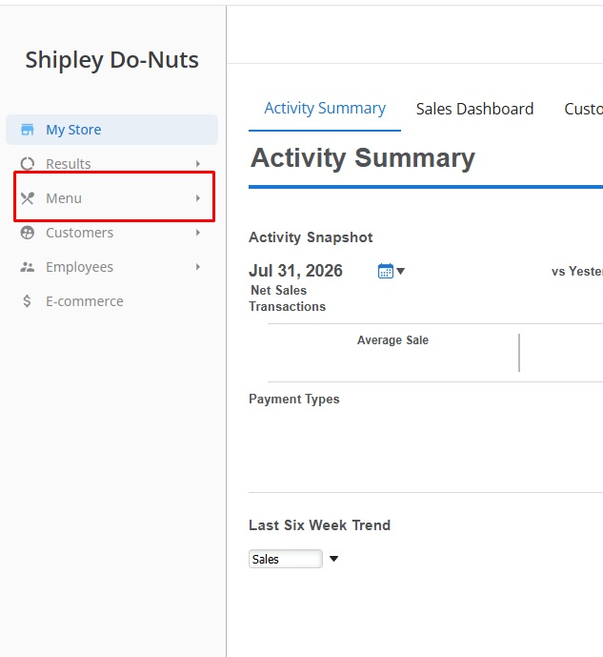

Step 2
Select Categories & Items.
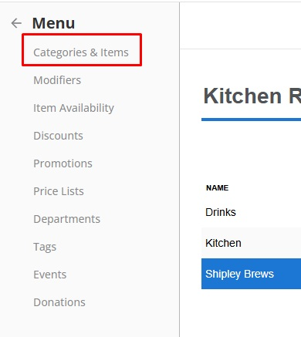

Step 3
Click Edit Multiple Items.
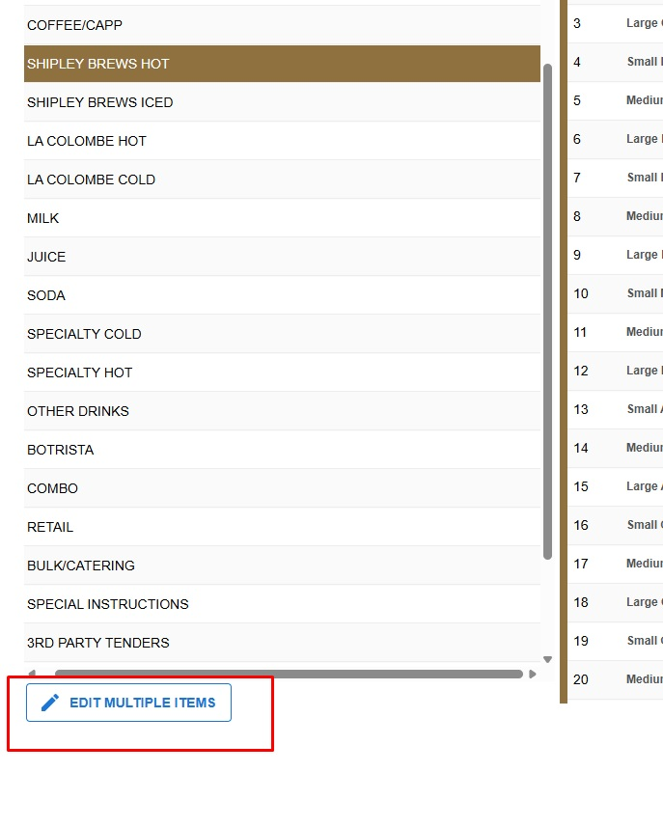

Step 4
From the category drop-down, select Coupon.
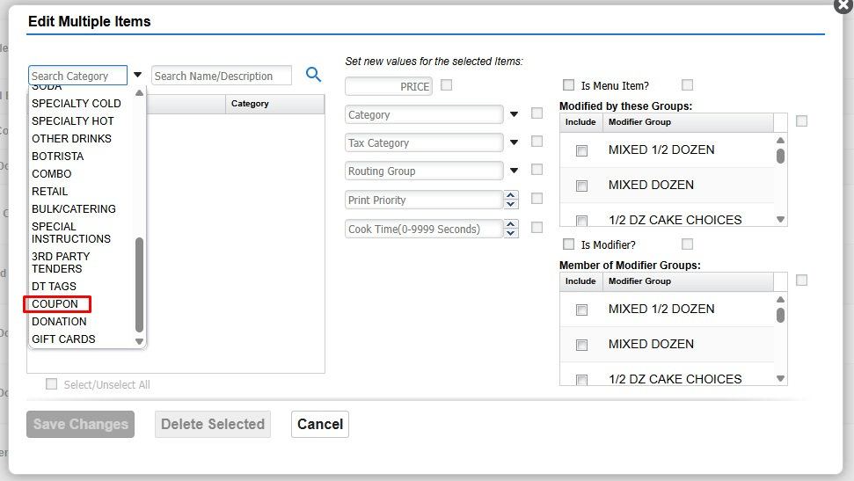

Step 5
Click Item Assignment.
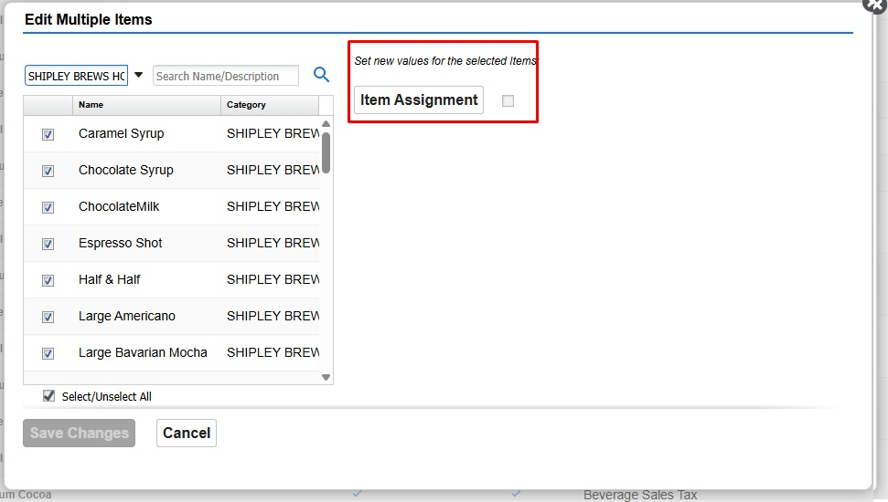

Step 6
Assign Trade-In Espresso and Coffee Sample. Tip: Use Ctrl+F to locate each promotion quickly. Click Done when finished.
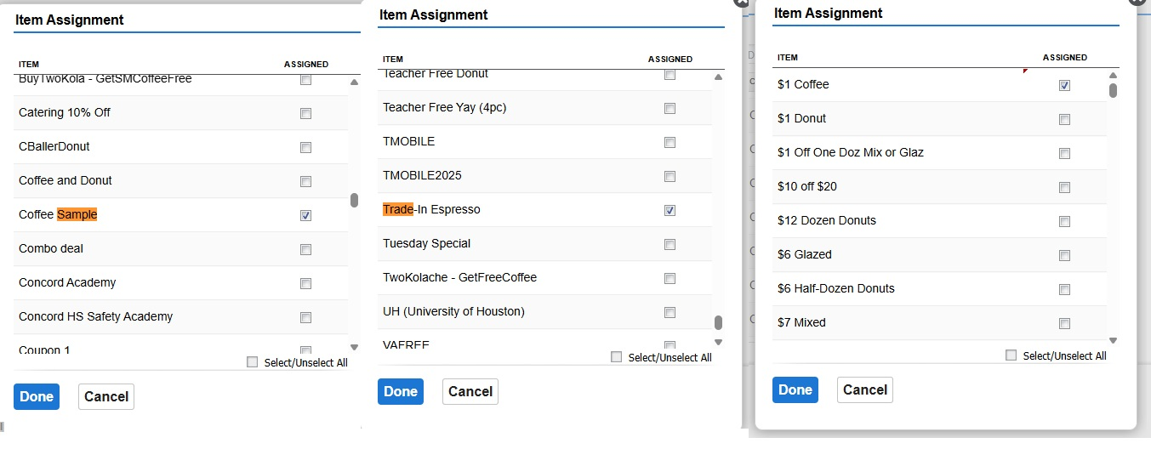

Part 2 – Add Promotions

Step 7
Go to Menu and select Promotions.
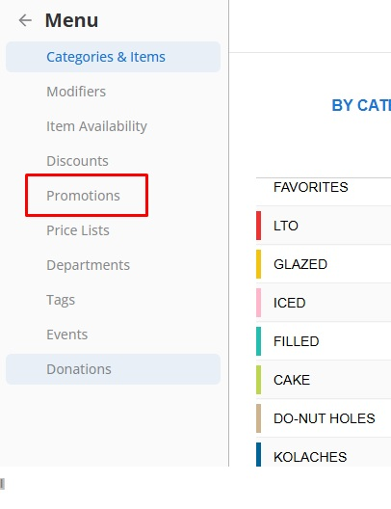

Step 8
Search for Trade-In Espresso and Coffee Sample, then assign them to the store.
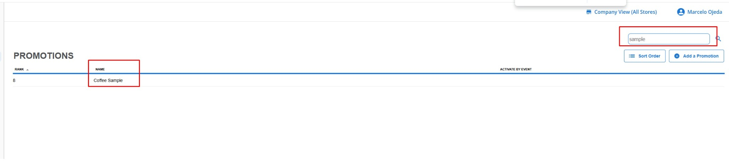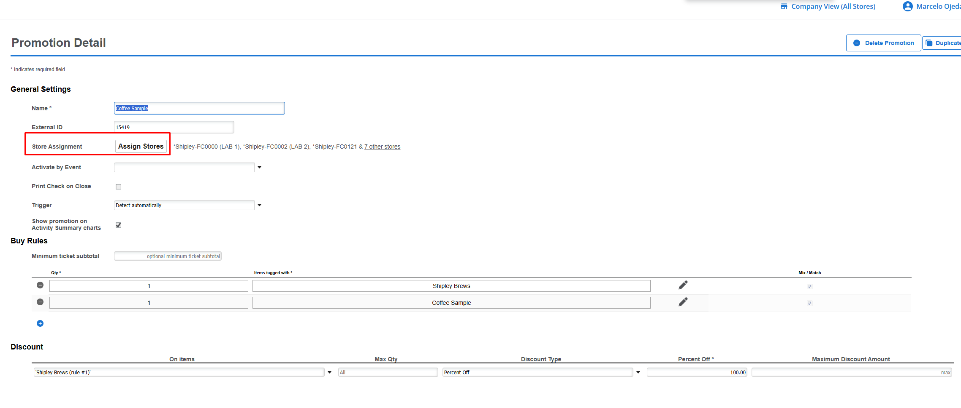

Step 9
Go to Menu > Events.
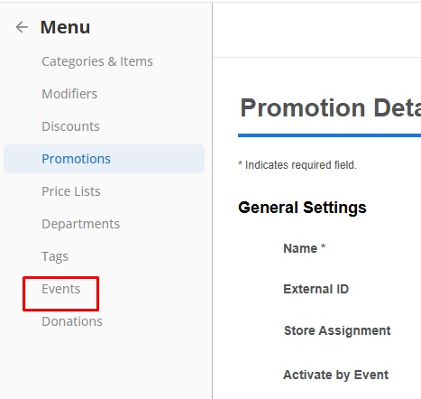

Step 10
Click Add an Event Schedule. Name it $1 Coffee FCXXXX (replace XXXX with the store number), select all seven days, and use the date range specified in the ticket. If no dates are provided, request them before proceeding.
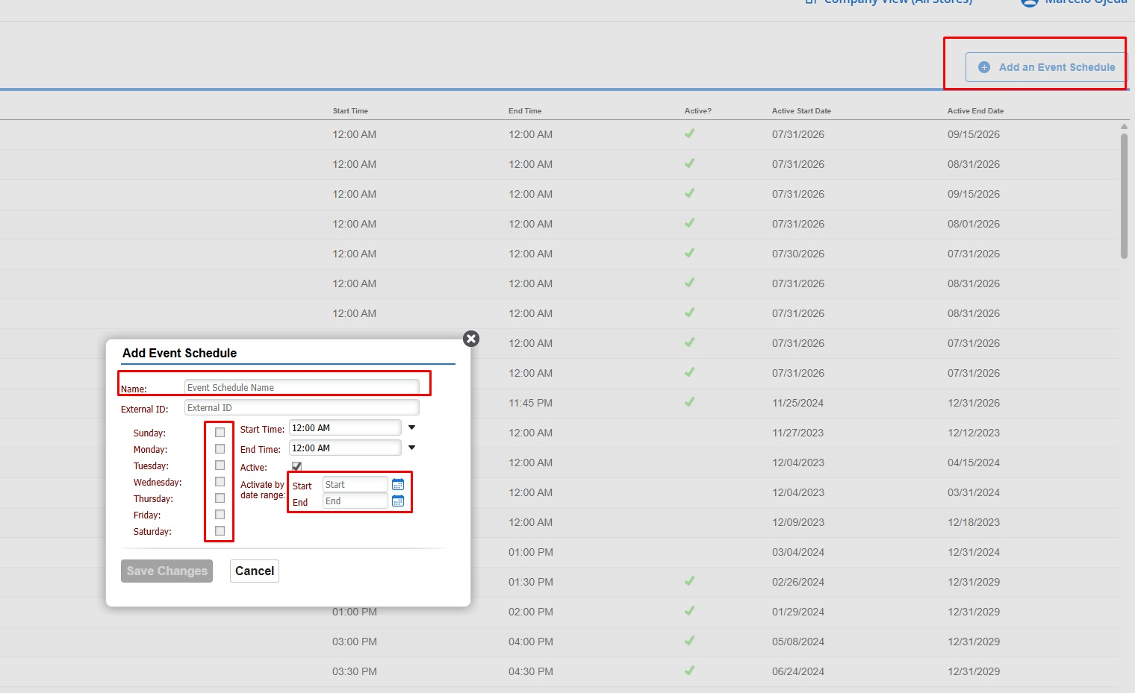

Step 11
Search for the $1 Coffee promotion and click Duplicate.
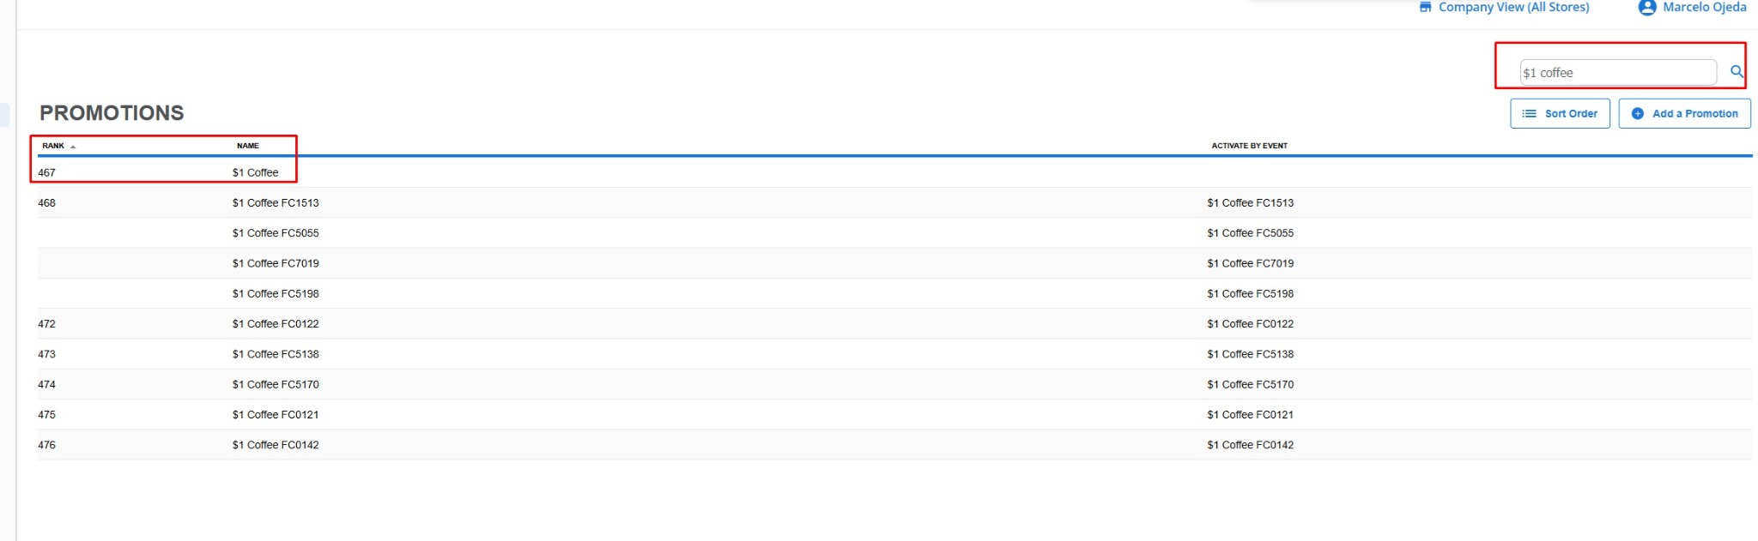

Step 12
Rename the promotion to $1 Coffee FCXXXX, assign it to the target store, and set Activate by Event to the event you created with the same name.
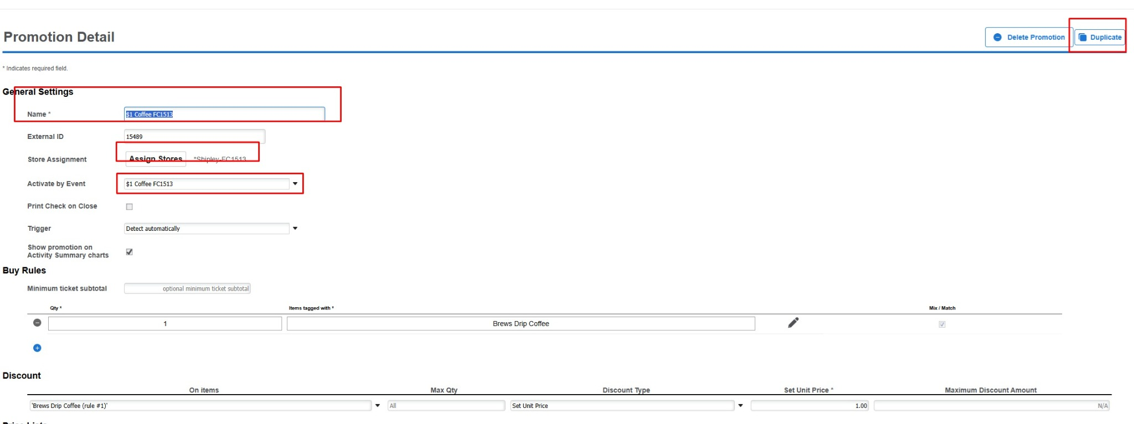
NEed to add the discount how to add - Reward-Free Medium Espresso

